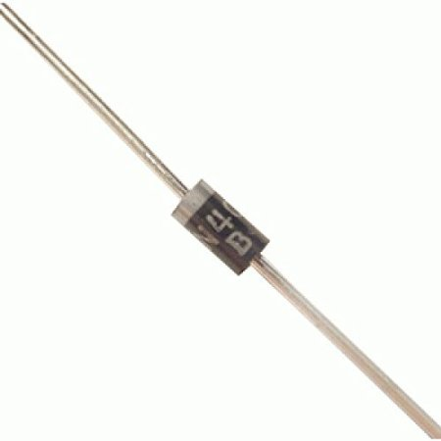

# Robomart IN4007 Diode (Pack of 50)

# Rs 150

# This is an p-n diode which is a type of two-terminal semiconductor diode based upon the p-n junction that conducts current in only one direction. <br>

# Made by joining a p-type semiconducting layer to an n-type semiconducting layer. <br>

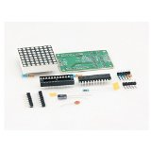

MAX7219 Dot Led Matrix Module MCU Control LED Display Module For Arduino ARM Raspberry AND Other MCU

Rs123.00

1. To satisfy electronic DIY hobbyists, we has developed MAX7219 Dot Matrix Module.<br>
2. It uses the Max7219 chip which do a great job on saving of MCU I/O. It can not only control each point individually, but also can be extended without limitation to meet your requirements on LED Sign, Team Logo and so on. <br>
3. A single module can drive an 8 * 8 common cathode lattice Module Operating voltage: 5V. <br>
4. Module size: 5 cm long X 3.2 cm wide X 1.5 cm high With four screws hole, aperture 3mm Module with input and output interfaces Supports multiple modules cascade Led colour: Red<br>

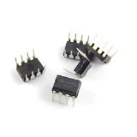

# 555 Timer IC (5Pcs)

Rs 93.00

1. The 555 timer IC is an integrated circuit (chip) used in a variety of timer, pulse generation, and oscillator applications. <br>
2. The 555 can be used to provide time delays, as an oscillator, and as a flip-flop element. <br>
3. Derivatives provide up to four timing circuits in one package<br>

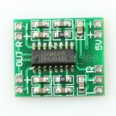

# PAM8403 digital power amplifier board 2 * 3 w class D power amplifier board high 2.5 ~ 5 v can be USB power supply

# Rs 162.00

# Features: Miniature digital power amplifier board 2x3w class D power amplifier board, Can work on USB power supply. <br>

# Good noise suppression Input audio should be via sheilded wire Dual channel stereo output 3 w + 3 w power <br>

# Works with 5v power supply can directly drive 4 Ω/8 Ω small speakers big output power, sound quality is good. <br>

# Unique without LC filter class D digital power board can use computer USB power supply directly Double panel wiring, super mini design, can easily fit in a variety of digital products high amplification efficiency made with solid plate welding machine Super size: 1.85 x 2.11 cm<br>

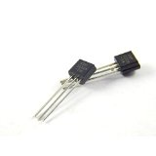

# 2N222 - NPN - Transistor (10 Pcs)

# Rs 70.00

# Transistor is one of the popular semiconductor device. It is used for switching and amplification. <br>

# When it comes to 2N222 then it is considered a very common transistor. <br>

# 2N2222 is a common NPN bipolar junctiontransistor (BJT) <br>

# 

# 20MHZ CRYSTAL OSCILLATORS(PACK OF 10)

115.00

1. It provide clock pulses of 20 Mhz frequency. It can be used as UART clock<br>
2. It allows integer division to common baud rates (96×115200 baud or 96×96×1,200 baud). <br>
3. It is a common clock for AVR microcontroller It uses the mechanical resonance of a vibrating crystal of piezoelectric material to create an electrical signal with a very precise frequency<br>